SENG2050 – Assignment 3 (RGMS)

User Manual

# Installing the Website

* Unzip the supplied assignment zip file
* Unzip the seng2050-assignment3 tomcat application to your default tomcat webapps directory
* Compile the .java class files using the following commands
  + cd seng2050-assignment3/WEB-INF/classes/rgms
  + javac -classpath ../../lib/javax.servlet-api-3.0.1.jar */*.java
* Confirm that java files compiled correctly
* Build the MySQL database using the supplied Database Configuration document

# Logging In

Users are able to log into the system using their username and a password. This can be done from the main entry page of the website shown in **Figure 1 Login Page** below. In order to access the system, a user is required to have an account. Users can register an account using the method described in **Registering Users**.

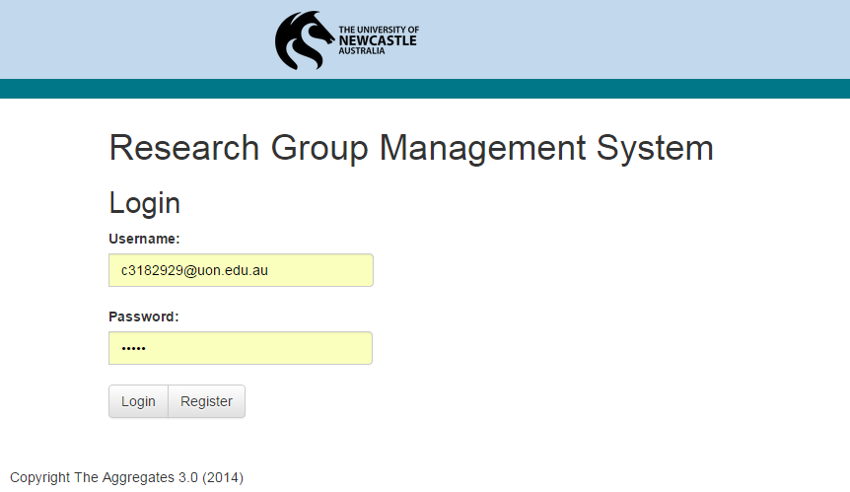

Figure 1 Login Page

Upon successful authentication, users are presented with their personal dashboard which displays their notifications, meetings, groups, and uploaded documents as shown in **Figure 2 User Dashboard**.

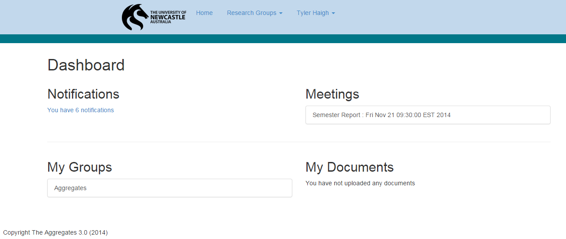

Figure 2 User Dashboard

# Registering Users

Registering users can be done from the User Registration page and can be accessed from the main entry point of the website. Here, users enter an email address for their username, and other details to join the system. Their account will need to be activated by coordinator who will be notified on successful account creation. Upon successful account creation, all coordinators in the system will be sent a notification allowing them to activate the user. Details on how to activate users as they join the system is described in **Activating Users**. The registration page is shown below in **Figure 3 Register Page**.

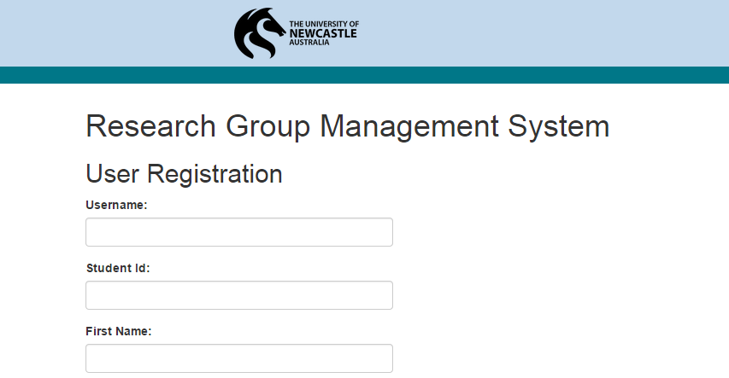

Figure 3 Register Page

# Notifications

Notifications are a means of informing users of important events that are happening within the system. They are created when a coordinator creates a meeting, a user joins the system, and when a user uploads a document, and other events. Users can access their notifications from their dashboard. There are different kinds of notifications that are displayed:

* Users joining the system display an “Activate” action
* Meetings and Document uploads display a link to the respective page and an action to “Dismiss” the notification
* Invitations to Groups display an “Add to Group” action

When an action button is clicked, the status of the action is displayed at the top of the page as seen in **Figure 4 Notifications Page**

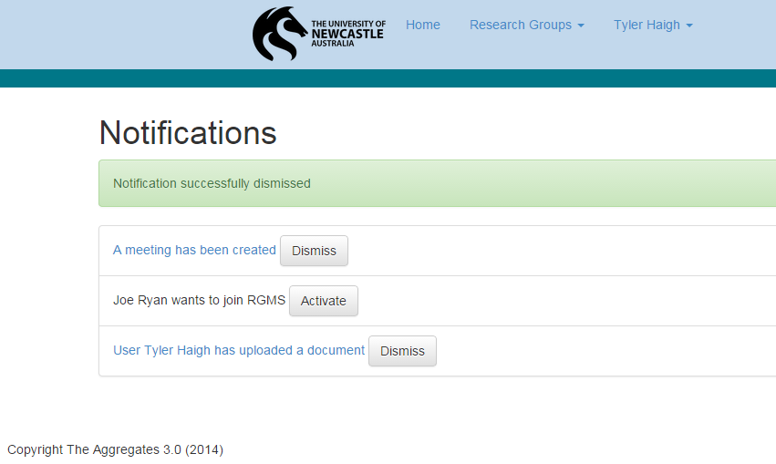

Figure 4 Notifications Page

# Meetings

Meetings can be created by coordinators and are sent to all users who are members of the group the meeting is made for. For more information on how meetings are created, refer to **Creating Groups**

Administrators can access the Create Groups page directly from the Administration Tools page. To create a group, an admin must supply a group name and a description. The administrator who created the group will then become the group’s coordinator allowing them to add users to the group. The Create Group page is shown in **Figure 12 Create Groups**.

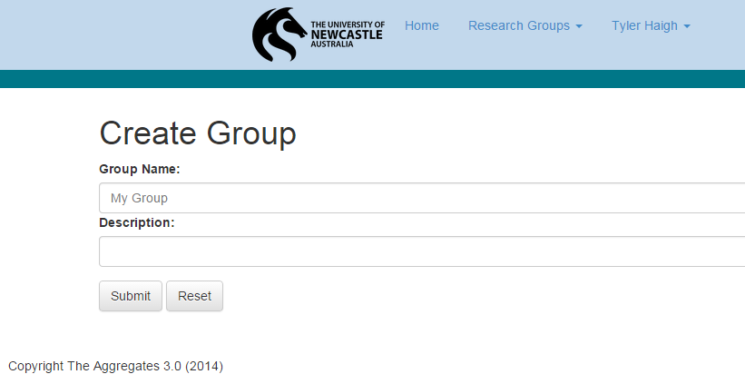

Figure 12 Create Groups

Creating Meetings.

Users will receive a notification as well as a meeting in their dashboard. Meetings contain a link to a page containing meeting details such as invited users, and the meeting date and time as shown in **Figure 5 Meeting Page**.

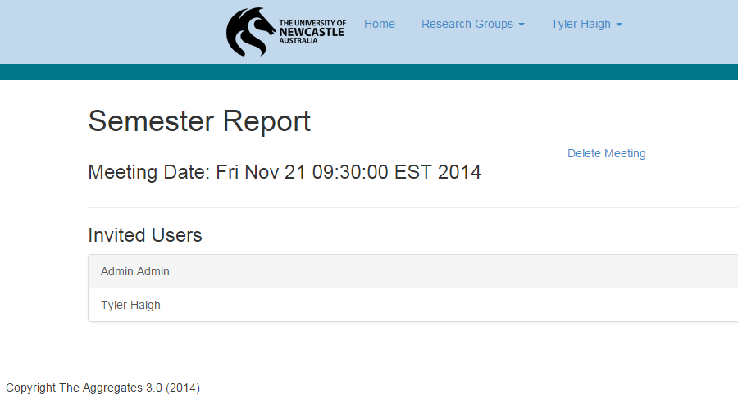

Figure 5 Meeting Page

# Groups

Groups form a core component of the system. They contain a list of members, meetings, discussions, and uploaded documents. Users can access group pages either from their dashboard, profile page, or from the “**Research Groups**” dropdown in the navigation bar. An example group page is provided in **Figure 6 Joining Groups**.

## Joining Groups

If a user is not a member of a Group, when they view the group page, a link will be displayed at the top of the page under the Group name allowing users to ask to join the group. This is shown in **Figure 6 Joining Groups** below. The coordinator of the group will receive a notification asking them to add the user to the group. For more information on notifications, refer to **Notifications**

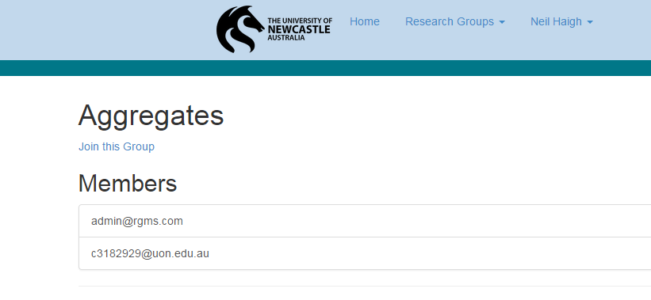

Figure 6 Joining Groups

# Profiles

Each user within the system has a profile that shows what groups they are in as well as other details about the user. Users can access their profile page from the “**View Profile**” link under their name in the navigation bar. If a user is viewing their own profile, the option to edit their profile is also displayed, as shown in **Figure 7 User Profile**. User profiles are visible to all users in the system.

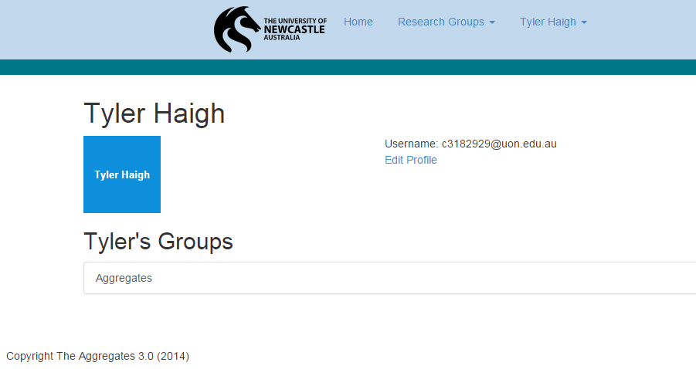

Figure 7 User Profile

## Editing Profiles

Users can access the Edit Profile page directly from their profile page. Here they can change their details and update them in the system as seen in **Figure 8 Editing Profiles**. Users are also able to upload an avatar of themselves to be displayed to other users in the system as well as change their password from here. When the user has finished editing their profile, they can select “**Submit**” to save their changes.

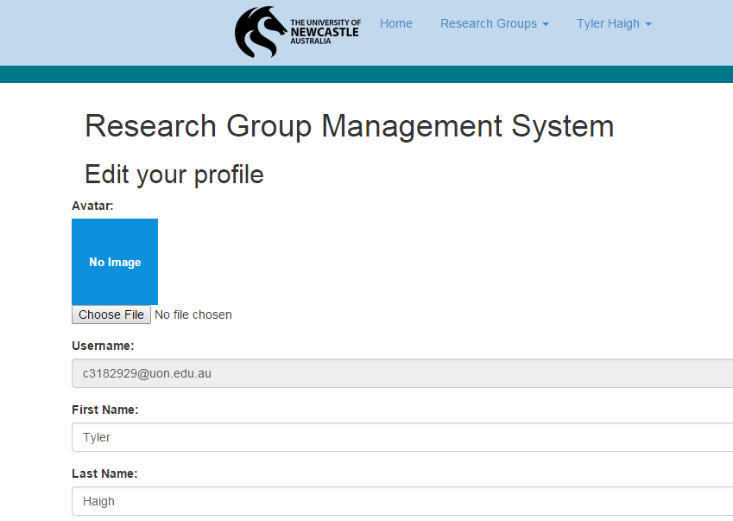

Figure 8 Editing Profiles

# Discussions

Users can create discussion threads from within their group’s page. Discussion threads can only be seen by members of the group. To create a new discussion thread, click “**Create Discussion**” on the Groups page. Discussion threads can have an optional document uploaded with it which maintains its own version control. An example of a Discussion being created is shown in **Figure 9 Creating a Discussion**.

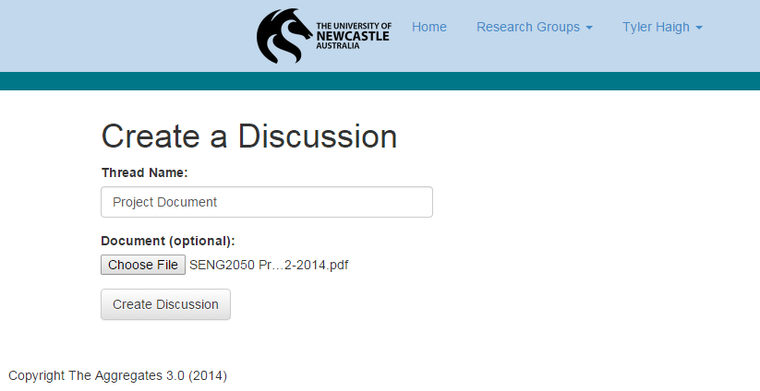

Figure 9 Creating a Discussion

The Discussion thread page shows a list of comments associated with the thread and which user posted the comment. This is shown in **Figure 10 Discussion Thread**.

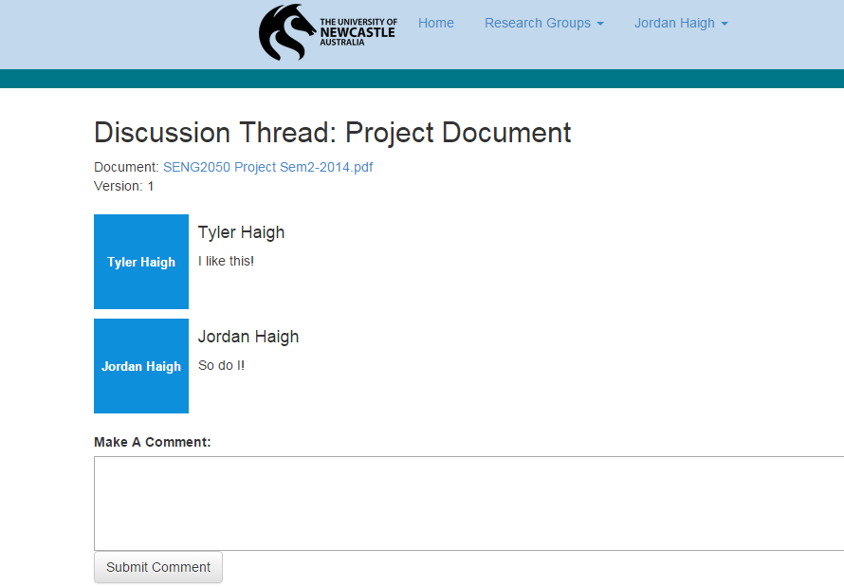

Figure 10 Discussion Thread

If a document was uploaded when the thread was created, users can download a copy from the discussion thread page.

# Administrative Users

Administrative users have additional access to the system, giving them the ability to create research groups, meetings, and view all users and groups that exist in the system. A list of all possible administration tools is shown in **Figure 11 Administration Tools**.

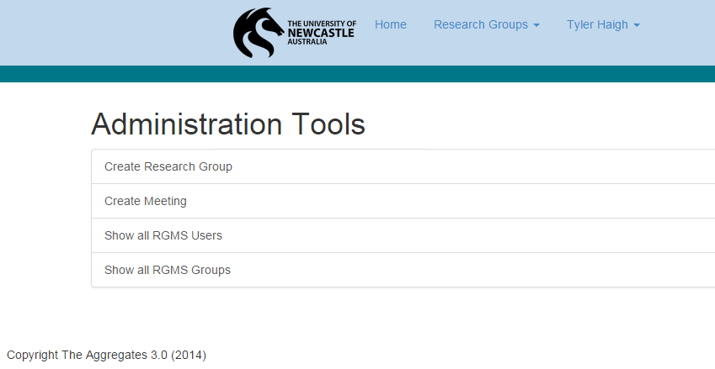

Figure 11 Administration Tools

## Creating Groups

Administrators can access the Create Groups page directly from the Administration Tools page. To create a group, an admin must supply a group name and a description. The administrator who created the group will then become the group’s coordinator allowing them to add users to the group. The Create Group page is shown in **Figure 12 Create Groups**.



Figure 12 Create Groups

## Creating Meetings

Administrators can access the Create Meetings page directly from the Administration Tools page. To create a meeting, the admin must supply a meeting description, the group the meeting will be made for, a date and a time for the meeting. A notification will be sent al all members of the group upon successful creation of a meeting. The Create Meeting page is shown in **Figure 13 Create Meetings**.

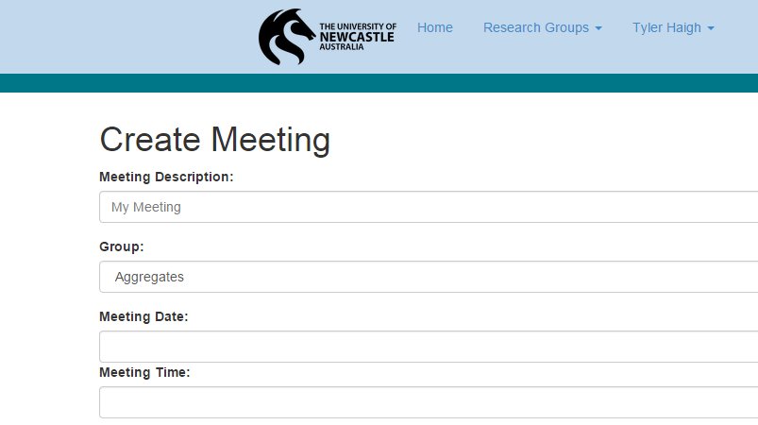

Figure 13 Create Meetings

## Activating Users

Activating users can be done by accessing the Notifications page directly from the dashboard. Coordinators will be able to activate a user’s account by clicking the “**Activate**” next to the notification.